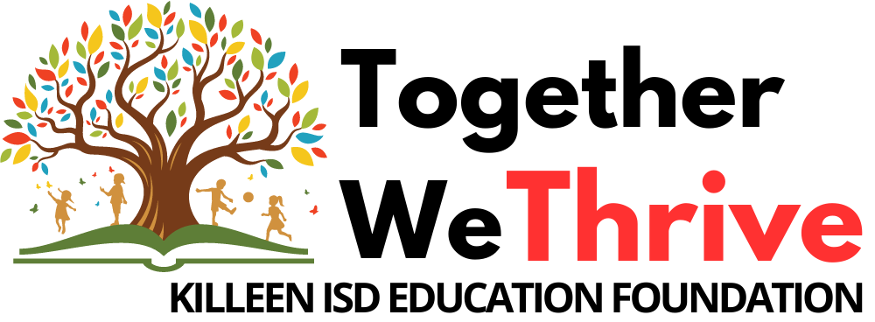
Thank you, Killeen ISD employees! Your generous donations have helped KISD become an innovative leader in learning.

The Education Foundation awarded over $356,500 in Grants and Scholarships during 2022-2023!
Professional Learning Grants
Classroom Teacher Grants & Rebates
Student Scholarships & Awards

Our 2023-2024 goals are to:
- Receive minimum $150,000 in campaign funds
- Involve minimum 44% of employees to participate (3,000 employees)
- Reward all KISD campuses with a rebate
Campus Rebate Program
For campuses who donate
$1,250 or more, one half
of what you give goes
back to your campus!

Drawings Each Friday!

When you participate in the Employee Contribution Campaign, you are eligible to win great prizes and gift certificates from
local restaurants/businesses
AND MUCH MORE!!

For more information contact the Education Foundation
office at 254.336.0182

2 Easy Steps to Pledge Your Gift:

- Complete the pledge form and select your donation option:

Monthly Payroll Deduction
(minimum payroll deduction is $5/month)
Note: Payroll Deduction is a 10-month pledge.
A $10 pledge = $100 total donation ($10/month for 10 months)

One-time Contribution by Check or Cash
Note: $5 minimum donation due to processing costs for checks; clip cash or check to form.
(No staples, please)

One-time Contribution by Credit Card
Note: $10 minimum credit card donation due to bank fees.

Visit www.KilleenEducationFoundation.org

- Give your pledge form and payment to your Campus Ambassador no later than
September 28, 2023.

50% BACK

